TEMPLATE FOR OPPORTUNITY DISCOVERY DOCUMENT
This document is to be used to introduce the business opportunity for a new idea or project. Your document should cover the six areas described below and should not exceed three pages. You should use the outputs from the worksheets completed through the WKI online Idea Scoping Toolkit to complete each section.

1.0 Technology Overview (two paragraphs maximum)
- Provide an overview of your idea and how it works in a user setting
- Use your napkin drawing
- Describe the 2-3 key attributes of your innovation
- Discuss at a high level how the concept works as compared to current approaches
- Use an analogy or metaphor to describe complex or novel innovations that are difficult to comprehend.

2.0 The Problem (one paragraph maximum)
- Discuss the business problem your idea proposes to solve
- Describe why this problem is important to a customer
- Profile the customer pain that your idea proposes to address
- Use customer language to describe this problem
- What is the metric that you will improve with your solution to the problem?

3.0 Business Opportunity (two paragraphs maximum)
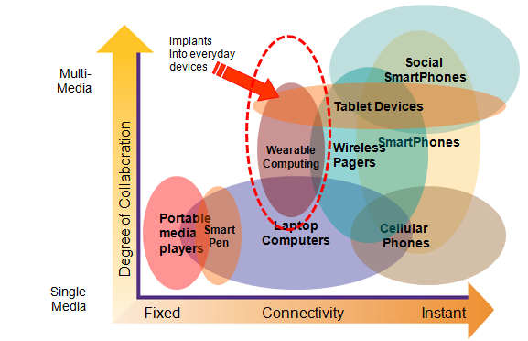
- Describe the industry landscape for your innovation
- Discuss the key market drivers pushing the industry landscape to change
- Discuss how the problem is being solved today through competing solutions and approaches.
Include your
category map in the document, but be sure to refer to it to discuss the landscape and your opportunity.
- Use your category map drawing to show the landscape and your opportunity area in this landscape
- Highlight your opportunity and why the timing is right to capture this opportunity.

4.0 Target Customers (2-3 paragraphs)
- A description of the customer segments that you propose to target with your idea
- Describe the burning pain these customer groups have that you can solve with your innovation
- A short profile of these target customers, including specifics on their buying process, product requirements and their expected use of the product
- A summary of any special criteria that need to be met to do business with the target customers.

5.0 Competitive Edge (one paragraph)
- An overview of the current competitors and their key strengths/weaknesses
- An explanation of your competitive advantage over these competitors
- A discussion of the key differentiator your idea offers over these competitors and why this is sustainable
- Note: you may elect to include your competitive radar in this section.

6.0 The Plan (two paragraphs)
- Describe what your goal is and how you plan to get there
- Summarize the progress you have made to date and the next major milestones
- Identify the key activities that are next in your plan and discuss what you require to accomplish them
- Identify the major risks in this plan and how you will mitigate these
- What do you require to achieve your milestones?

